ESA Position Paper regarding fugitive emissions testing with helium and hydrogen

Hydrogen is expected to play an increasingly important role in the future energy landscape. From power generation, energy storage and alternative source to power vehicles the applications are widespread.

Sealing devices for hydrogen applications need to meet specific criteria, including high reliability, resistance to hydrogen embrittlement, and compatibility with the harsh conditions associated with hydrogen use. Materials and designs that prevent hydrogen leakage and maintain the integrity of containment systems are crucial for the safe and efficient utilization of hydrogen across these diverse applications.

Another aspect for seal performance are fugitive emissions, the unintended release of gases or vapors from industrial processes or equipment, which pose environmental and safety concerns.
Here the ESA and its members are more frequently asked now how their sealing devices are performing with hydrogen.

Most sealing devices perform already reliably in hydrogen applications. Regarding the emission performance a lot of tests have been carried out with different gasket materials. Because hydrogen is highly flammable and can form explosive mixtures with air special safety measures have to be implemented to perform these tests. When compared with the standard test gas helium for emission testing it was found that the hydrogen results are very similar. Figure 1 shows test results for a graphite gasket which was tested with both media.
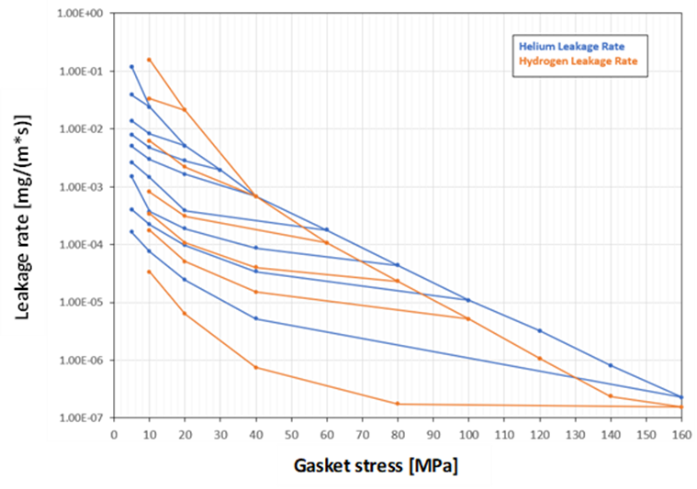

Figure 1: Leakage rate of helium vs hydrogen for graphite gasket

At low stresses up to 30 MPa hydrogen showed slightly higher leakage rates compared to helium. For higher flange stresses this reversed. All measured leak rates were below the L0.01 limit of the German TA-Luft regulations except for those measured at a very low gasket stress.

Testing with graphite packing materials for valve stem sealing showed similar results regarding the measured leakage rates for both gases.

Conclusion

Until now most emission tests with helium and hydrogen have shown leak rates in the same ballpark range. Unlike hydrogen though, helium, is very unreactive. It will not burn or oxidise and doesn’t form compounds, all of which make it safe and easy to handle. Because of this, researchers prefer helium as the main test gas due to the reduced safety risks.

