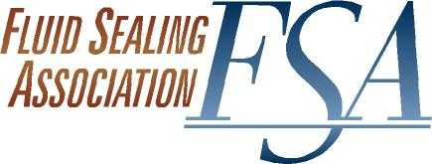

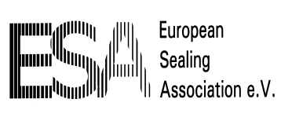
AGENDA
COMPRESSION PACKING
WORKING GROUP
Go-to-Meeting Conference
September 10, 2018

- Approval of Agenda
- Handbook
- Release Process
- Joint FSA-ESA Projects
  - LCC Power consumption formula
  - Valve Packing Study
  - ESA PD 002 (BS 4371)
  - K Factor study/ASTM WK 56884
- Education projects
  - FSA Webinar(s)
  - ESA Packing training material
  - Knowledge Base
- Standards & Regulations
  - API 622 – 624 - 641- 602 – 623 – 621 - 608
  - ISO 15848
  - EN 16752
  - Emission Regulations
    - Mexico - IED - EPA -States - Canada
  - WTO - Tariffs
  - EU Drinking water standards
  - Food contact Graphite
  - EPA Clean Water
  - PFOA
  - Other
- Publications
  - Sealing Sense Articles
  - KCI Pump Engineer
  - Chemical Engineering
  - BIC
  - Flow Control
- Outreach Projects
  - VMA
  - Fluor/Canada Valve Users Group
  - A&M TPS
  - HI
  - API – Refining Meeting
  - Power Gen – FLMUG - EPRI
  - Indian Sealing Association contact
  - Chinese Sealing Association contact
  - STLE
  - BHRG
  - Valve World/Pump Summit November 2018
  - Industrial Valve Summit May 2019
  - EDF PPrime sealing workshop
- New Business
- Next Session
- Adjourn
hva 09/10/2018

