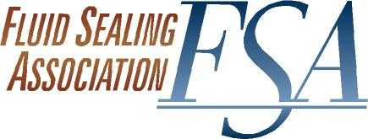

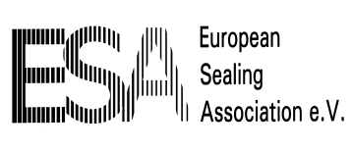
AGENDA
COMPRESSION PACKING
WORKING GROUP
Go-to-Meeting Conference
February 4, 2019

- Approval of Agenda
- Handbook
  - Release
- Joint FSA-ESA Projects
  - LCC Power consumption formula
  - Valve Packing Study
  - ESA PD 002 (BS 4371)
  - K Factor study/ASTM WK 56884
- Knowledge Base
  - Material generation
- Education projects
  - FSA Webinar(s)
  - ESA Packing training material
- Standards & Regulations
  - Spreadsheet updates
  - API 622 – 624 - 641- 602 – 623 – 621 – 608 – 600 -607
  - ISO 15848
  - EN 16752
  - Emission Regulations
    - Mexico - EPA -States – Canada – IED - TaLuft
  - WTO – Tariffs - Brexit
  - EU Drinking water standards
  - Food contact Graphite
  - EPA Clean Water
  - PFOA
  - Other
- Publications
  - Sealing Sense Articles
  - KCI Pump Engineer
  - Chemical Engineering
  - BIC
  - Flow Control
- Outreach Projects
  - VMA
  - Fluor/Canada Valve Users Group
  - A&M TPS
  - HI
  - API
  - Power Gen – FLMUG – EPRI - MUGAUG
  - Indian Sealing Association contact
  - Chinese Sealing Association contact
  - STLE
  - BHRG
  - Valve World November 2018 report
  - Industrial Valve Summit May 2019
- New Business
- Next Session
- Adjourn
hva 02/04/2019

